**BucHunt Team 2 Documentation**

* **Database**
  + Entity-Relationship Diagram
  + Explanation of Table Fields
  + Use Cases
    - Hunt with a single player
    - Hunt with multiple players
* **API**
* **Release Notes**

# **Database**

[Microsoft documentation on Transact-SQL Data Types](https://learn.microsoft.com/en-us/sql/t-sql/data-types/data-types-transact-sql?view=sql-server-ver16)

## Entity-Relationship Diagram

## Explanation of Table Fields

|  |  |  |
| --- | --- | --- |
| **Table Name** | | |
| Field  **Bold indicates primary key**  Underline indicates foreign key | Data type | Explanation of field |

|  |  |  |
| --- | --- | --- |
| **Codes** | | |
| **Access Code** | VARCHAR | Unique code used by a player to join a hunt |
| Status | TINYINT | Used to indicate whether an access code is:   1. **Active** 2. **Pending Invite** 3. **Disabled** |
| User ID | INT | Used to associate an access code to a specific player |
| Hunt ID | INT | Used to associate an access code to a specific hunt |

|  |  |  |
| --- | --- | --- |
| **Hunt_Group_Members** | | |
| **ID** | INT | Identifier for each instance of a hunt group member |
| User ID | INT | Used to associate a player with a hunt group |
| Group ID | INT | Used to associate the hunt group with the hunt group member instance |

|  |  |  |
| --- | --- | --- |
| **Hunt_Groups** | | |
| **Group ID** | INT | Identifier for a hunt group |
| Date Started | DATETIME2 | Datetime the hunt group began the hunt |
| Hunt ID | VARCHAR | Used to associate a hunt group to a specific hunt |

|  |  |  |
| --- | --- | --- |
| **Hunts** | | |
| **Hunt ID** | INT | Identifier for a hunt |
| Title | VARCHAR | Text to be displayed as the title for a hunt |
| Theme | VARCHAR | Text to indicate the hunt’s theme |
| Invitation Text | VARCHAR | Text to be sent to a player if they are invited to the hunt |
| URL | VARCHAR | Web address to access the hunt |
| Status | TINYINT | Used to indicate whether a hunt is:   1. **Active** 2. **Pending** 3. **Inactive** |
| Date Created | DATETIME2 | Datetime the hunt was created on the server |
| Start Date | DATETIME2 | Datetime set for the hunt to start |
| End Date | DATETIME2 | Datetime set for the hunt to end |

|  |  |  |
| --- | --- | --- |
| **Scores** | | |
| **ID** | INT | Identifier for each score instance |
| Time Taken | TIME | Total time elapsed between starting and completing a hunt. Used to calculate players’ rank |
| User ID | INT | Used to associate the score with a player |
| Hunt ID | INT | Used to associate the score with a hunt |

|  |  |  |
| --- | --- | --- |
| **Task_Progress** | | |
| **ID** | INT | Identifier for each task progress instance |
| Complete | BIT | Indicates whether the task has been completed |
| Timestamp | DATETIME2 | Datetime the task was completed |
| Group ID | INT | Used to associate the task progress with a hunt group |
| Task ID | INT | Used to associate with a specific task |
| User ID | INT | Used to associate task progress with a player. Also used to indicate which player in a hunt group completed the task |

|  |  |  |
| --- | --- | --- |
| **Tasks** | | |
| **Task ID** | INT | Identifier for a task |
| Label | VARCHAR | Text to be displayed as the label for the task |
| Answer | VARCHAR | Value used as acceptance criteria for a player to complete the task |
| Latitude | FLOAT | Latitude coordinates of the task |
| Longitude | FLOAT | Longitude coordinates of the task |
| Display Order | INT | Number indicating where this task should be displayed along with the other task(s) in the associated hunt |
| QR Image URL | VARCHAR | Web address containing an image of the QR code |
| QR Code Value | VARCHAR | Text value of the QR code |
| Hunt ID | INT | Used to associate a task to a specific hunt |

|  |  |  |
| --- | --- | --- |
| **Users** | | |
| **User ID** | INT | Identifier for a player account |
| Username | VARCHAR | Player assigned name, also should be unique to the player |
| First Name | VARCHAR | Player’s first name |
| Last Name | VARCHAR | Player’s last name |
| Email | VARCHAR | Player’s email address |
| Phone Number | INT | Player’s 9-digit phone number |
| Admin | BIT | Indicates whether the user is an admin or not |

## Use Cases

### **Hunt with a single player**

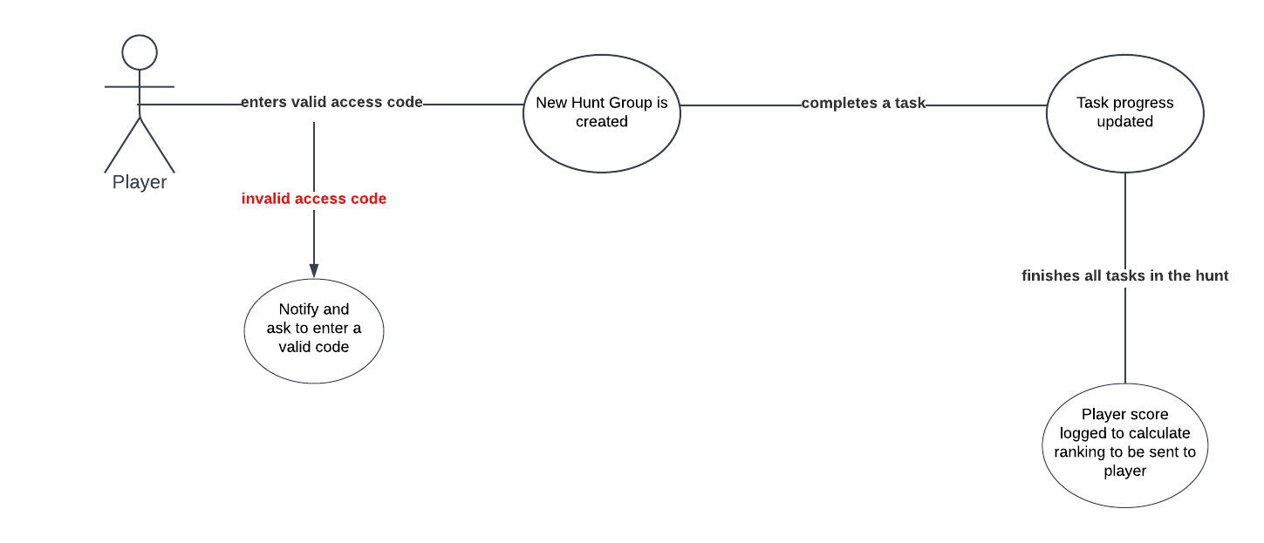

### **Hunt with multiple players**

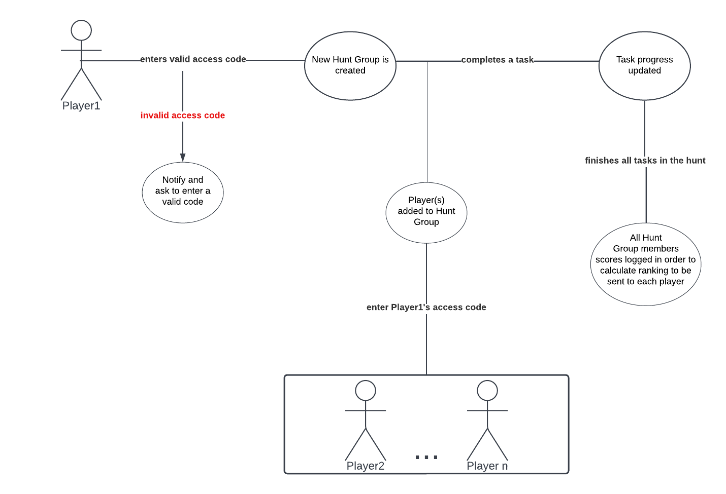

# **API**

# **Release Notes**